**TinyFlix QA Bug Report**

**Bug Report 1**

**Title**

Duplicate Video Thumbnails Displayed

**Severity**

* Medium

**Component**

Home Page / Video Grid

**Environment**

* Browser: Chrome 120.0.6099.130
* OS: Windows 11
* Screen Size: 1920x1080
* Device: Desktop

**Steps to Reproduce**

1. Open the homepage ([http://localhost:5173](http://localhost:5173/))
2. Scroll through the video grid

**Expected Behavior**

Each video should be unique and shown only once.

**Actual Behavior**

The same video appears multiple times with the same thumbnail and title.

**Screenshots/Videos**

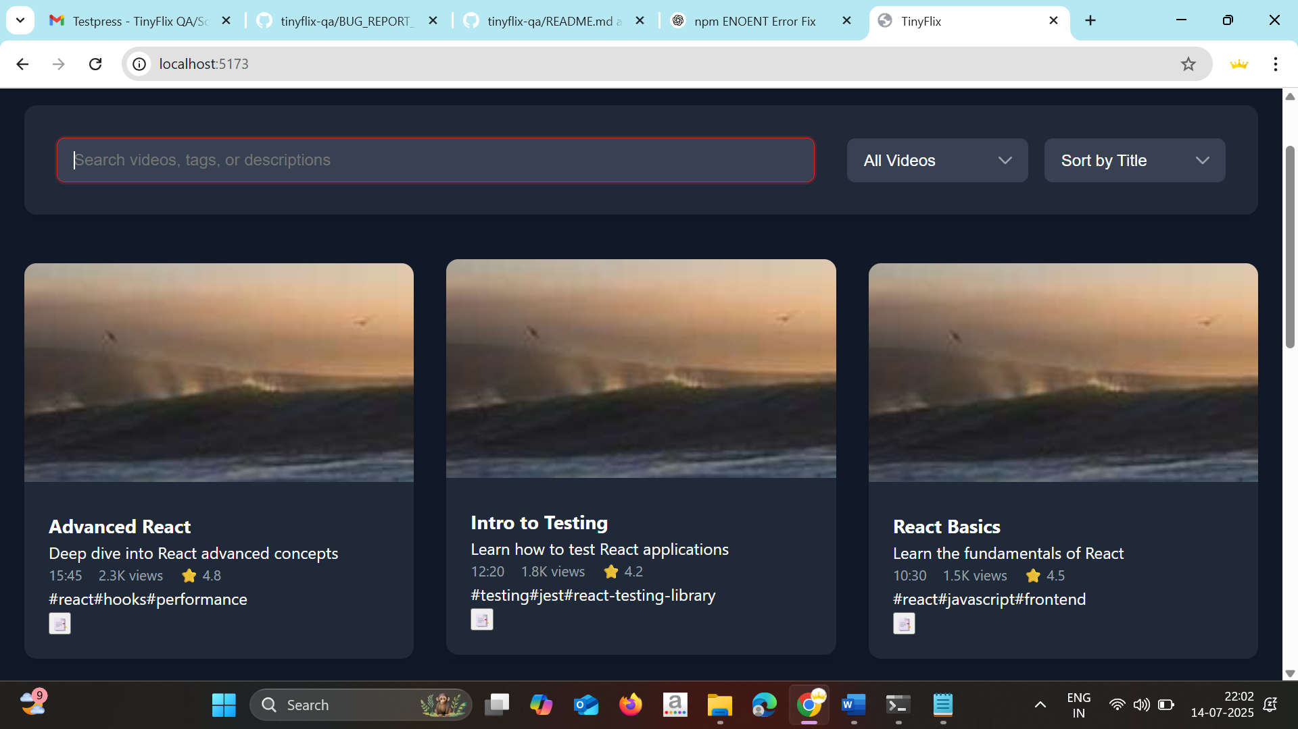**Additional Context**

Likely due to repeated data entries or lack of unique video ID handling.

**Suggested Fix**

Ensure video list rendering is based on unique IDs.

**Bug Report #2**

**Title**

Sign Up and Sign In Buttons Don't Respond

**Severity**

* Critical

**Component**

Navigation Header (Auth)

**Environment**

* Browser: Chrome 120.0.6099.130
* OS: Windows 11
* Screen Size: 1920x1080
* Device: Desktop

**Steps to Reproduce**

1. Launch the app.
2. Click the Sign In or Sign Up button.

**Expected Behavior**

Modal or navigation to the auth screen should occur.

**Actual Behavior**

Nothing happens. No routing, modal, or console log.

**Screenshots/Videos**

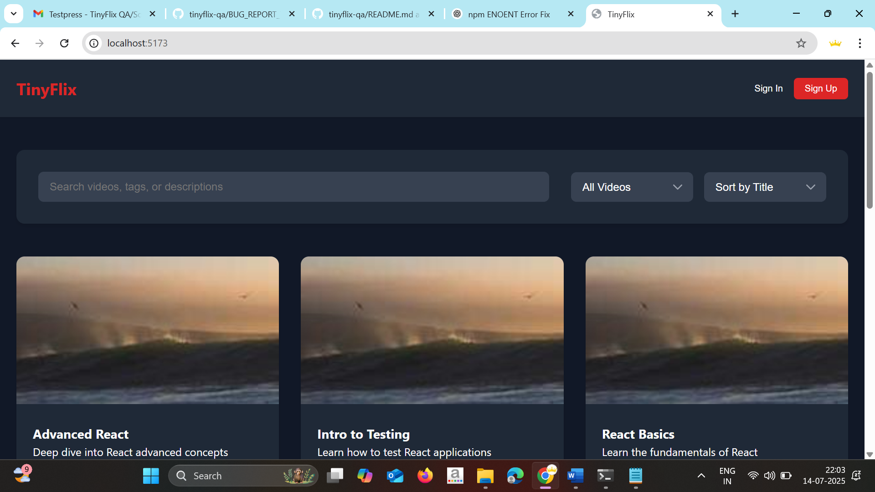

**Additional Context**

May be missing route linkage or event binding.

**Suggested Fix**

Check routing logic and ensure buttons are properly linked to handlers.

**Bug Report #3**

**Title**

Video Player UI Too Small and Controls Are Unclear

**Severity**

* Medium

**Component**

Video Player

**Environment**

* Browser: Chrome 120.0.6099.130
* OS: Windows 11
* Screen Size: 1920x1080
* Device: Desktop

**Steps to Reproduce**

1. Click any video on homepage
2. View the video player layout

**Expected Behavior**

Video should appear large and controls should be visible and intuitive.

**Actual Behavior**

Player is narrow, icons are small and unclear.

**Screenshots/Videos**

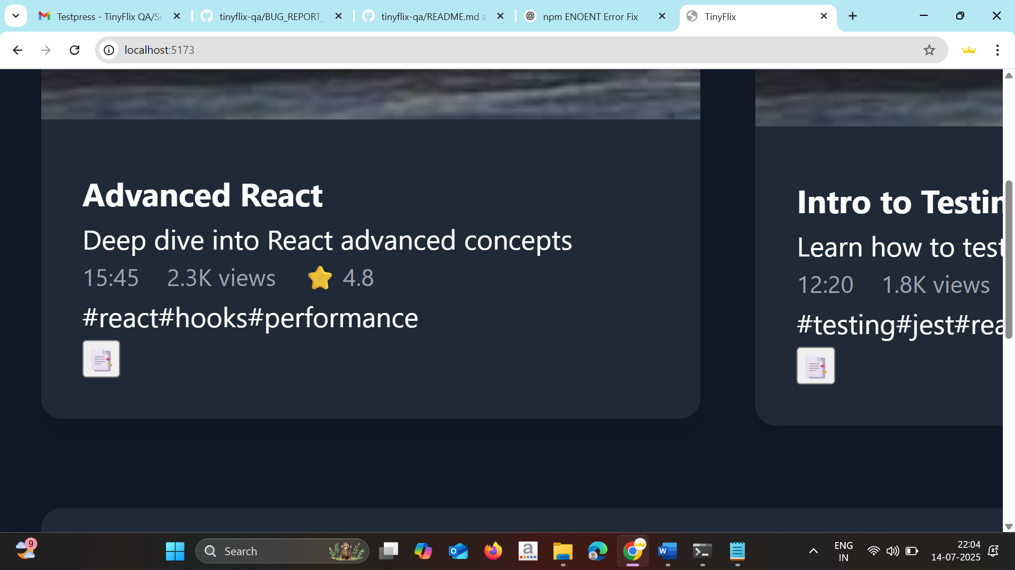

**Additional Context**

User experience and accessibility issue.

**Suggested Fix**

Improve layout using Flex/Grid. Add labels/tooltips to icons. Use WCAG-compliant sizing.

**Bug Report #4**

**Title**

No Error Message on Empty Search or Failed API

**Severity**

* Medium

**Component**

Search

**Environment**

Same as above

**Steps to Reproduce**

1. Enter a gibberish string like "asdhakshd"

**Expected Behavior**

User sees "No results found"

**Actual Behavior**

Page appears blank

**Screenshots/Videos**

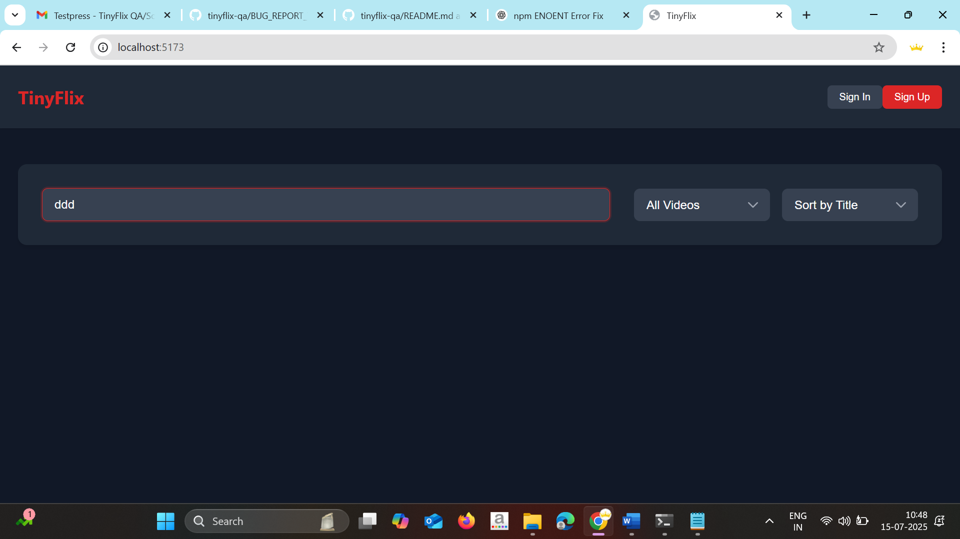**Additional Context**

Can confuse users and affect usability.

**Suggested Fix**

Add fallback UI for empty or failed search results.

**Bug Report #5**

**Title**

Comment Submission Doesn’t Validate Empty Input

**Severity**

* Medium

**Component**

Comments

**Environment**

Same as above

**Steps to Reproduce**

1. Open a video
2. Submit empty comment

**Expected Behavior**

Comment form should validate and prevent submission

**Actual Behavior**

Allows submission of empty input

**Additional Context**

Basic form validation is missing

**Suggested Fix**

Use required input validation before form submission

**Bug Report #6**

**Title**

Video Fails to Play Without Showing Error Message

**Severity**

* High

**Component**

Video Player

**Environment**

* Browser: Chrome 120.0.6099.130
* OS: Windows 11
* Screen Size: 1920x1080
* Device: Desktop

**Steps to Reproduce**

1. Open any video in the player
2. Click play
3. Encounter a playback failure (e.g., unstable connection or brief disconnect)

**Expected Behavior**

An error message should appear such as: "Failed to play video. Please check your internet connection."

**Actual Behavior**

No error message is shown; player remains unresponsive

**Screenshots/Videos**

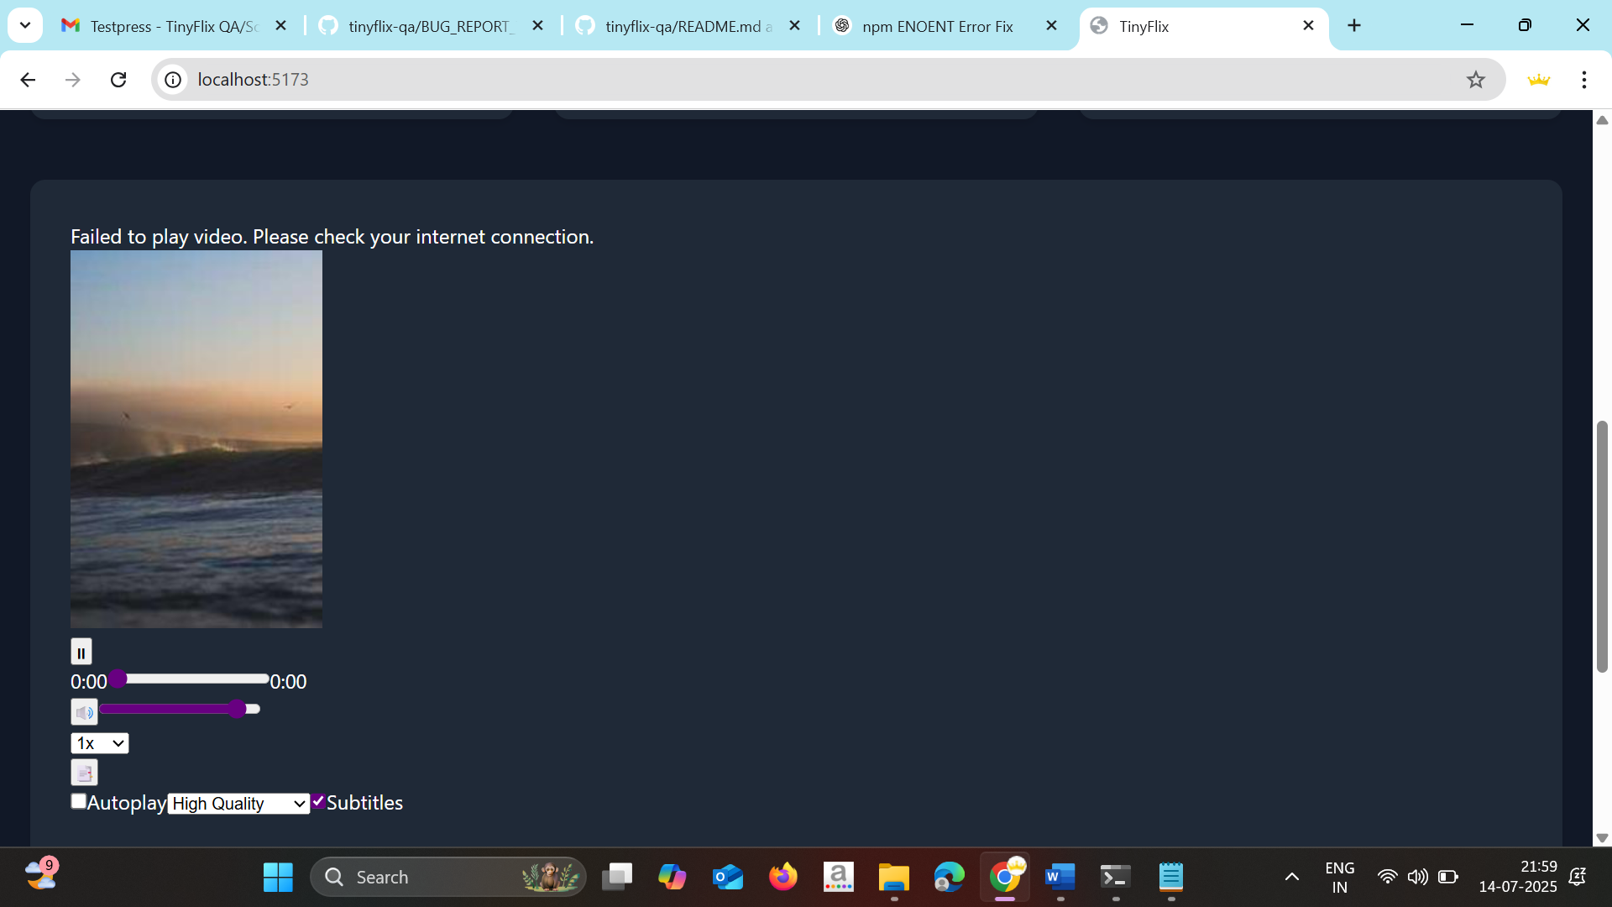

**Additional Context**

Affects user clarity on issue; no fallback UI triggered.

**Suggested Fix**

Add event listener for video error and display clear fallback message to the user

**Bug Report #7**

**Title**

App Loads with Empty State When No Videos Exist

**Severity**

* Low

**Component**

Homepage Video Grid

**Environment**

Same as above

**Steps to Reproduce**

1. Simulate API returning empty list

**Expected Behavior**

Display message like "No videos available"

**Actual Behavior**

Blank space with no messaging

**Additional Context**

Could be due to missing conditional rendering

**Suggested Fix**

Render empty state message when no data is present

**Bug Report #8**

**Title**

Bookmark UI Is Too Small and Not Easily Noticeable

**Severity**

* Low

**Component**

Bookmarks (UI/UX)

**Environment**

* Browser: Chrome 120.0.6099.130
* OS: Windows 11
* Screen Size: 1920x1080
* Device: Desktop

**Steps to Reproduce**

1. Open any video
2. Click to view or add bookmarks

**Expected Behavior**

Bookmark section should be prominently visible and easily clickable

**Actual Behavior**

Bookmark UI is too small, hard to notice, and not user-friendly

**Additional Context**

Users may not find or use the feature

**Suggested Fix**

Increase size, spacing, and positioning of the bookmark UI. Consider tooltips and icon enhancements.

**Bug Report #9**

**Title**

Search Input Accepts Invalid Data Without Feedback

**Severity**

* Medium

**Component**

Search Bar

**Environment**

* Browser: Chrome 120.0.6099.130
* OS: Windows 11
* Screen Size: 1920x1080
* Device: Desktop

**Steps to Reproduce**

1. Type an invalid string (e.g., special characters or long gibberish)
2. Press Enter

**Expected Behavior**

Should display a message like "No results found"

**Actual Behavior**

Search silently fails with no visual feedback

**Additional Context**

User is left confused when search doesn’t work as expected

**Suggested Fix**

Implement validation or catch failed searches with a friendly error state

**BUG #9**

**Title**

Video Thumbnails Change Daily and Are Not Relevant

**Severity**

* Medium

**Component**

Video Grid / Home Page Content

**Environment**

* Browser: Chrome 120.0.6099.130
* OS: Windows 11
* Screen Size: 1920x1080
* Device: Desktop

**Steps to Reproduce**

1. Open the homepage of the app.
2. Visit again the next day or refresh multiple times.
3. Observe the video thumbnails shown.

**Expected Behavior**

Thumbnails should remain consistent and relevant to the video titles or content.

**Actual Behavior**

Thumbnails change daily or on reload and sometimes appear irrelevant to the video being shown.

**Screenshots/Videos**

[Attach if available]

**Additional Context**

Could confuse users or reduce content credibility if thumbnails don’t match video context.

**Suggested Fix**

Ensure thumbnails are tied to video metadata in a persistent and consistent way. Validate the source of thumbnails and avoid using dynamic placeholders.

**Bug Report #10**

**Title**

Comment Likes Are Duplicated and Not User-Specific

**Severity**

* Medium

**Component**

Comments Section (Engagement/Interaction)

**Environment**

* Browser: Chrome 120.0.6099.130
* OS: Windows 11
* Screen Size: 1920x1080
* Device: Desktop

**Steps to Reproduce**

1. Open any video with comments
2. Like a comment
3. Refresh or revisit — the like count increases without tracking who liked
4. Repeat like action from same user — count increases again

**Expected Behavior**

Likes should be user-specific and allow only one like per user per comment. Repeated likes should toggle (like/unlike).

**Actual Behavior**

Any user can like the same comment multiple times; no user validation is applied.

**Screenshots/Videos**

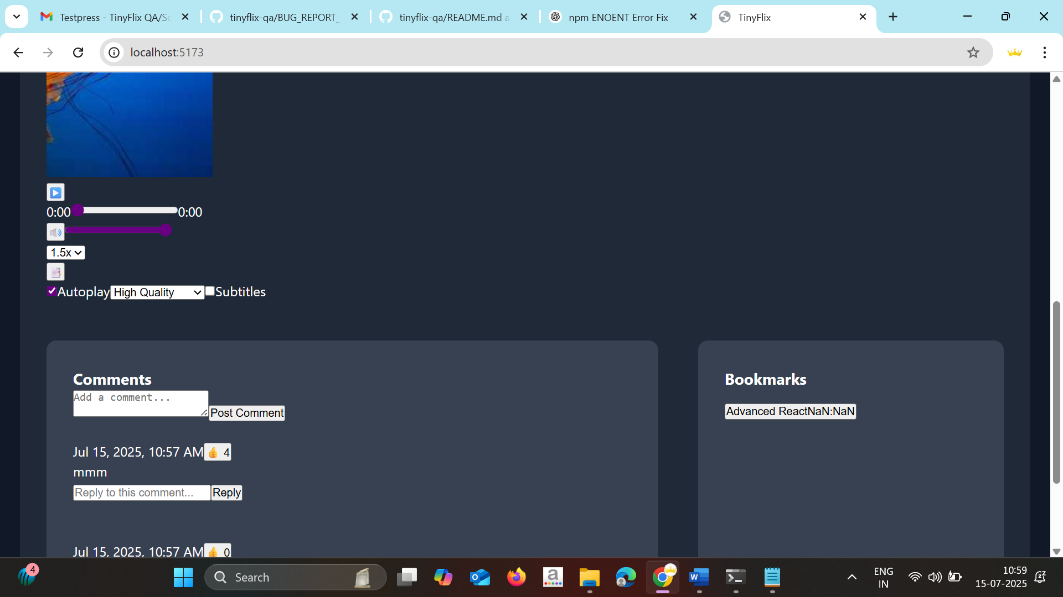**Additional Context**

This may lead to inflated like counts and unfair comment rankings.

**Suggested Fix**

Associate each like with a user ID (or session at minimum), and restrict to one like per comment per user. Allow toggling for unlike.

**Bug Report #11**

**Title**

Search Bar Not Working After Navigating to a Video

**Severity**

* Medium

**Component**

Search Bar / Video Detail Page

**Environment**

* Browser: Chrome 120.0.6099.130
* OS: Windows 11
* Screen Size: 1920x1080
* Device: Desktop

**Steps to Reproduce**

1. Open the homepage
2. Click on any video to view the detail/player page
3. Try using the search functionality again

**Expected Behavior**

Search bar should remain accessible and functional across all views

**Actual Behavior**

Search bar either becomes unresponsive or is not present

**Additional Context**

Affects discoverability and navigation continuity

**Suggested Fix**

Ensure the search bar is rendered globally and hooked to active input handlers across views

**Bug Prioritization**

**Critical Bugs**

1. Bug #2 - Sign In/Up Buttons Don’t Work

**High Priority Bugs**

1. Bug #6 - Video Playback Fails Without Error Message

**Medium Priority Bugs**

1. Bug #1 - Duplicate Video Thumbnails
2. Bug #3 - Video Player UI
3. Bug #4 - No Feedback on Search
4. Bug #5 - Comment Validation Missing
5. Bug #9 - Invalid Search Feedback Missing
6. Bug #10 - Inconsistent Thumbnails
7. Bug #10 - Duplicate Likes
8. Bug #11 - Search Not Working After Navigation

**Low Priority Bugs**

1. Bug #7 - Empty State UI Missing
2. Bug #8 - Small Bookmark UI

**Summary of Findings**

**Total Bugs Identified: 12**

**Distribution by Severity**

* Critical: 1
* High: 1
* Medium: 8
* Low: 2

**Distribution by Component**

* Video Player: 3
* Search/Filter: 4
* Bookmarks: 1
* Comments: 2
* Accessibility: 0
* Performance: 0
* Other: 2

**Recommendations**

**Immediate Actions**

1. Fix broken Sign In/Sign Up routing
2. Implement missing search and playback logic
3. Add error handling to video and UI interactions

**Long-term Improvements**

1. Add test coverage for video playback, likes, and search
2. Improve UI responsiveness and visual hierarchy
3. Standardize error handling and fallback UI across the app